**Maclaurin theory: N-layer model**

Because the gravitational potential $V$ is linear in the density $ρ$, we may use a principle of superposition, such that the total potential at any point in space is the sum of the partial potentials produced by concentric constant-density spheroids. Figure 1 illustrates this concept for a three-layer model.

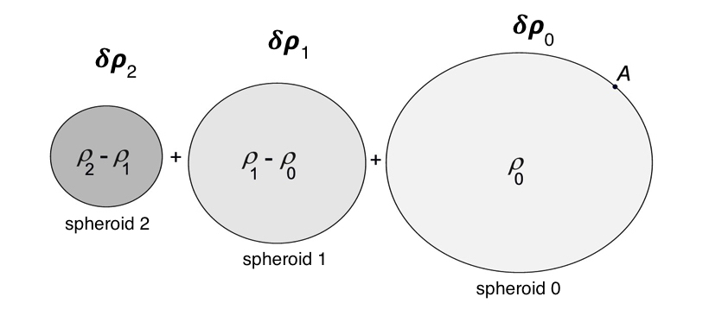

Fig. 1 – Method of superposition of Maclaurin spheroids, for the case $N=3$. The innermost spheroid has a density $δρ_{2}$, the middle spheroid has a density $δρ_{1}$, and the outer spheroid has a density $δρ_{0}=$ $ρ_{0}$. We define $δρ_{i}=ρ_{i}-ρ_{i-1}$ for $i>0$, and $δρ_{0}=ρ_{0}$.

When the spheroids are stacked (i.e., made concentric), the total densities become $ρ_{2}, ρ_{1}, ρ_{0}.$ The point “A” is a typical point on the outermost level surface.

Let the equatorial radius of the outermost spheroid be $a_{0}$, and let the equatorial radii of the nested spheroids be $a_{0}>a_{1}>a_{2}>…>a_{N-1}$. The total gravitational potential at some point “A” on the outermost level surface is

$$V_{ext, A}=\frac{G}{r}\left(\sum_{k=0}^{∞}{D_{0,2k}r^{-2k}P_{2k}\left(μ\right)}+\sum_{k=0}^{∞}{D_{1,2k}r^{-2k}P_{2k}\left(μ\right)}+…+\sum_{k=0}^{∞}{D_{N-1,2k}r^{-2k}P_{2k}\left(μ\right)}\right)$$

where

$$D_{0, 2k}= \frac{2πρ_{0}}{2k+3}\int_{-1}^{1}{dμ}P_{n}\left(μ\right){r_{0}\left(μ\right)}^{2k+3}$$

$$D_{1, 2k}= \frac{2π(ρ_{1}-ρ_{0})}{2k+3}\int_{-1}^{1}{dμ}P_{n}\left(μ\right){r_{1}\left(μ\right)}^{2k+3}$$

etc., where the relation $r_{i}=r_{i}(μ)$ is the surface equipotential of the *i*-th layer. The zero-degree values are given by

$$D_{0, 0}= \frac{2πρ_{0}}{3}\int_{-1}^{1}{dμ}{r_{0}\left(μ\right)}^{3}$$

$$D_{i, 0}= \frac{2π(ρ_{i}-ρ_{i-1})}{3}\int_{-1}^{1}{dμ}{r_{i}\left(μ\right)}^{3}$$

and so we have

$$M=\sum_{i=0}^{N-1}{D_{i,0}}=\sum_{i=0}^{N-1}{\frac{2π δρ_{i}}{3}\int_{-1}^{1}{dμ}{r_{i}\left(μ\right)}^{3}}$$

Dimensionless forms:

Let

$$Ma_{0}^{2k}J_{i,2k}=-D_{i,2k}$$

and

$$ξ_{i}=r_{i}(μ)/a_{0}$$

The total gravitational potential at surface point “A” can thus be rewritten

$$V_{ext, A}=\frac{GM}{r}\left(1-\sum_{i=0}^{N-1}{\sum_{k=1}^{∞}{J_{i,2k}{ξ_{0}\left(μ\right)}^{-2k}P_{2k}\left(μ\right)}}\right)$$

or, rearranging the order of summation,

$$V_{ext, A}=\frac{GM}{r}\left(1-\sum_{k=1}^{∞}{\left(\sum_{i=0}^{N-1}{J_{i,2k}}\right){ξ_{0}\left(μ\right)}^{-2k}P_{2k}\left(μ\right)}\right) (1)$$

where

$$J_{i,2k}=-\left(\frac{3}{2k+3}\right)\frac{δρ_{i}\int_{0}^{1}{dμ}P_{n}\left(μ\right) {ξ_{i}\left(μ\right)}^{2k+3}}{\sum_{j=0}^{N-1}{δρ_{j}\int_{0}^{1}{dμ}{ξ_{j}\left(μ\right)}^{3}}} (2)$$

The external potential measured at an arbitrary point $ξ_{0}\left(μ\right)$ on the planet’s surface can be simply written as

$$V_{ext, A}=\frac{GM}{r}\left(1-\sum_{k=1}^{∞}{J_{2k}{{ ξ}_{0}\left(μ\right)}^{-2k}P_{2k}\left(μ\right)}\right)$$

where

$$J_{2k}=\sum_{i=0}^{N-1}{J_{i,2k}} (3)$$

The total value of a given $J_{2k}$ (measurable in principle by a spacecraft) is just a linear superposition of the contribution from each of the $N$ spheroids. We can use expression (3) to exhibit the relative contributions (weight functions) for the zonal harmonics.

The CMS method proceeds by iteration. We determine the shapes of the equipotential surfaces of the spheroids, $ξ_{i}\left(μ\right)$, and then we use those shapes to calculate the harmonic coefficients $J_{i,2k}$ for each layer. The resulting equations for the surface shapes are then fed into the next iteration. However, the $J_{i,2k}$ are not sufficient to calculate the equipotential shapes of interior spheroids. If there are no interior spheroids because we have only a single Maclaurin spheroid, they would be. To see what else we need, let us compute the total gravitational potential at an arbitrary point “B” on the interface (level surface) between spheroid $i$ and spheroid $i-1:$

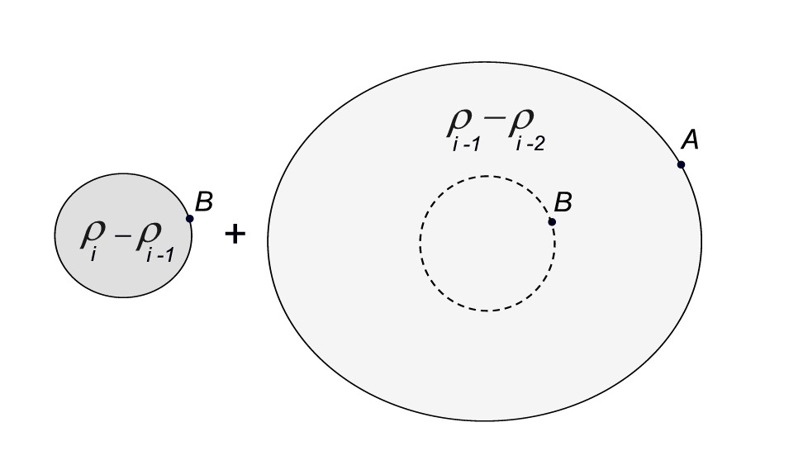

Fig. 2 – Schematic diagram illustrating the computation of three contributions to the gravitational potential at point “B” located at $\left(r,μ\right)$ on an interior interface. B lies on the oblate surface of the left-hand spheroid of density $δρ_{i}$. B also lies on a spherical surface of radius $r$ in the right-hand spheroid of density $δρ_{i-1}$.

We easily calculate the external potential at the surface of a spherical mass distribution with radius $r$ and constant density $δρ_{i-1}$ (shown as a dashed circle in Fig. 2). We give this potential the subscript $i$ because it is one of the three contributions to the potential at the surface of spheroid $i$:

$${V"}_{i,ext, B}=\frac{G}{r}\frac{4π δρ_{i-1}}{3}r^{3}$$

We calculate the internal potential at point “B” due to the mass distribution with constant density $δρ_{i-1}$ external to the dashed circle in Fig. 2:

$${V'}_{i,int, B}=\frac{2πG}{r}δρ_{i-1}\sum_{k=0}^{∞}{r^{2k+1}P_{2k}\left(μ\right)}\int_{-1}^{1}{dμ'}P_{2k}\left(μ'\right)\int_{r}^{r_{i-1}\left(μ'\right)}{dr^{'} {r'}^{-2k+1}}$$

Then we calculate the external potential at point “B” due to the mass distribution with constant density $δρ_{i}$ (left-hand shaded distribution in Fig. 2). Etc. (more to come)